OS Theory Assignment 1
National University of Computer & Emerging Sciences, Karachi
CS2006 – Operating Systems | Spring 2026
Student Name | Roll Number | Course | Due Date
Abdullah Sonija | k240013 | CS2006 – OS | 23rd Feb 2026

Task: Add a Custom 'Hello World' System Call to Linux Kernel 6.13

Objective
This document details every step taken to: (1) download Linux kernel 6.13, (2) rename it with roll number k240013 so that uname -r displays the roll number, (3) add a custom 'Hello World' system call, (4) compile and install the kernel, and (5) verify the system call works correctly.

Step 1 – Install Required Build Dependencies
Before downloading the kernel, all tools needed to configure and compile it were installed:
sudo apt-get update
sudo apt-get install -y build-essential libncurses5-dev libncurses-dev bison flex libssl-dev libelf-dev bc
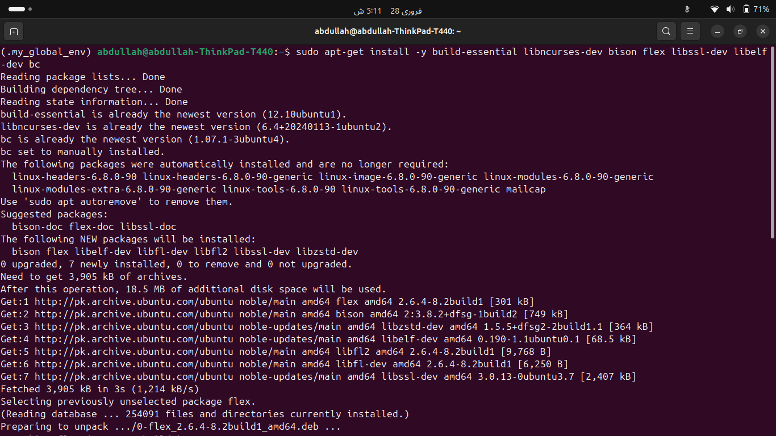
Fig 1.1 – Running apt-get update
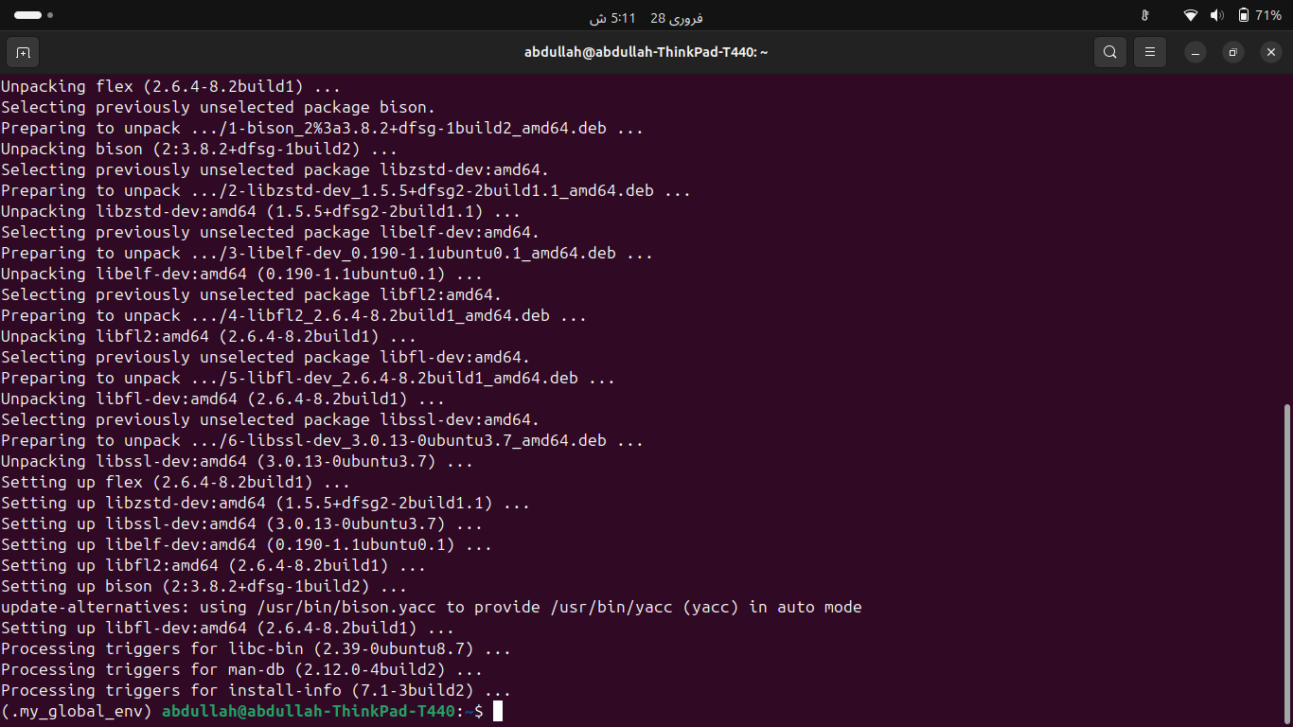
Fig 1.2 – Installing all build dependencies successfully

Step 2 – Download the Linux Kernel Source
Kernel 6.13 was downloaded from kernel.org using wget and extracted:
cd ~
wget https://cdn.kernel.org/pub/linux/kernel/v6.x/linux-6.13.tar.xz
tar xf linux-6.13.tar.xz
cd linux-6.13
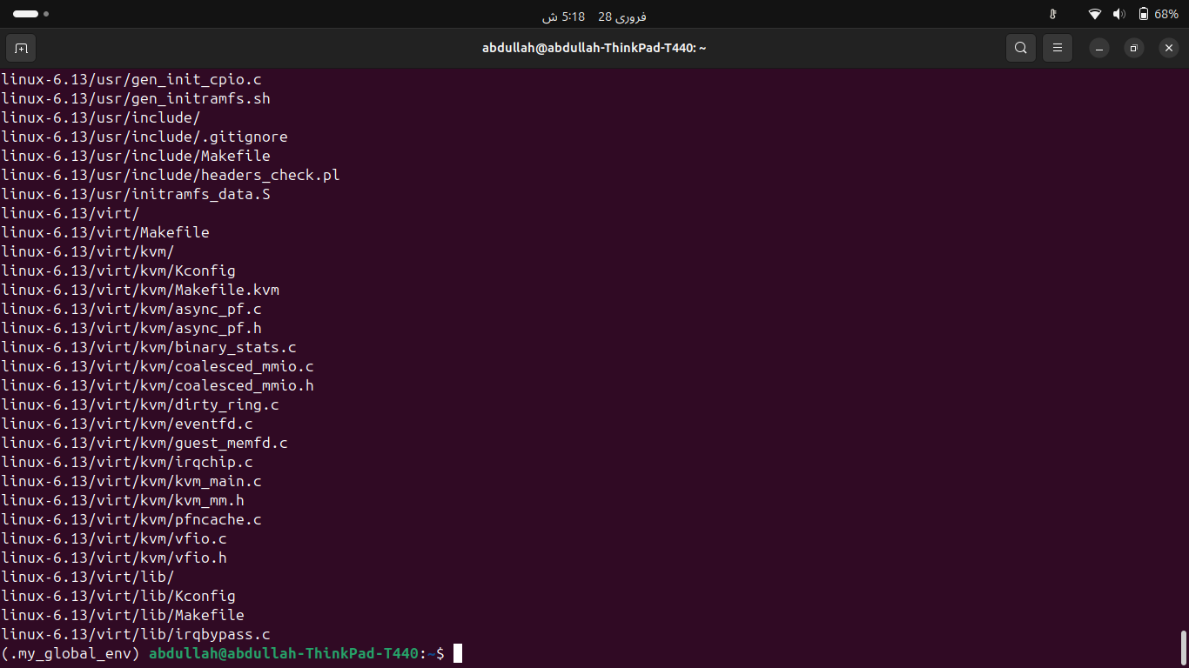
Fig 2.1 – Kernel tarball downloaded and extracted

Step 3 – Rename the Kernel with Roll Number
The EXTRAVERSION field in the top-level Makefile was edited to set the kernel version name to the roll number:
nano Makefile
EXTRAVERSION = -k240013
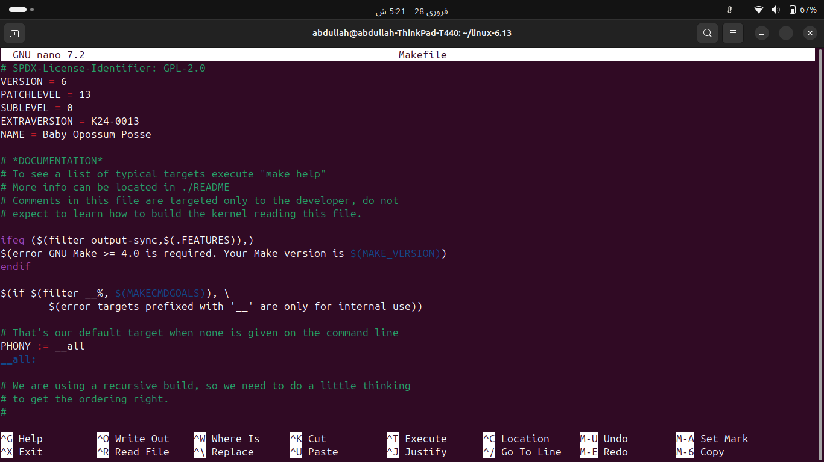
Fig 3.1 – Makefile opened in nano showing EXTRAVERSION = -k240013

Verified the change was saved correctly:
head -5 Makefile
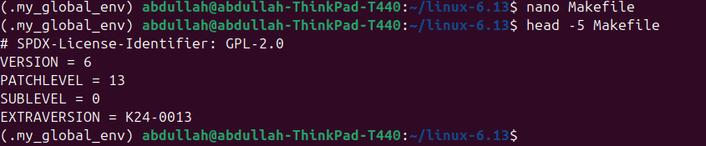
Fig 3.2 – head -5 Makefile confirming EXTRAVERSION value

Step 4 – Add the 'Hello World' System Call

4a – Create the System Call Source File
A new directory was created and the system call implemented:
mkdir hello
nano hello/hello.c
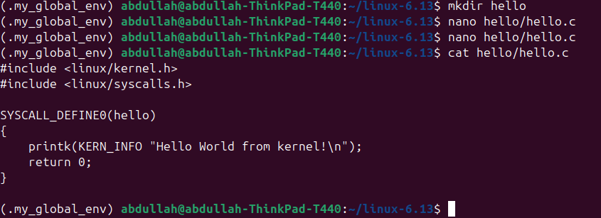
Fig 4.1 – hello/hello.c with SYSCALL_DEFINE0(hello) implementation

4b – Create the Makefile for hello/
nano hello/Makefile
obj-y := hello.o
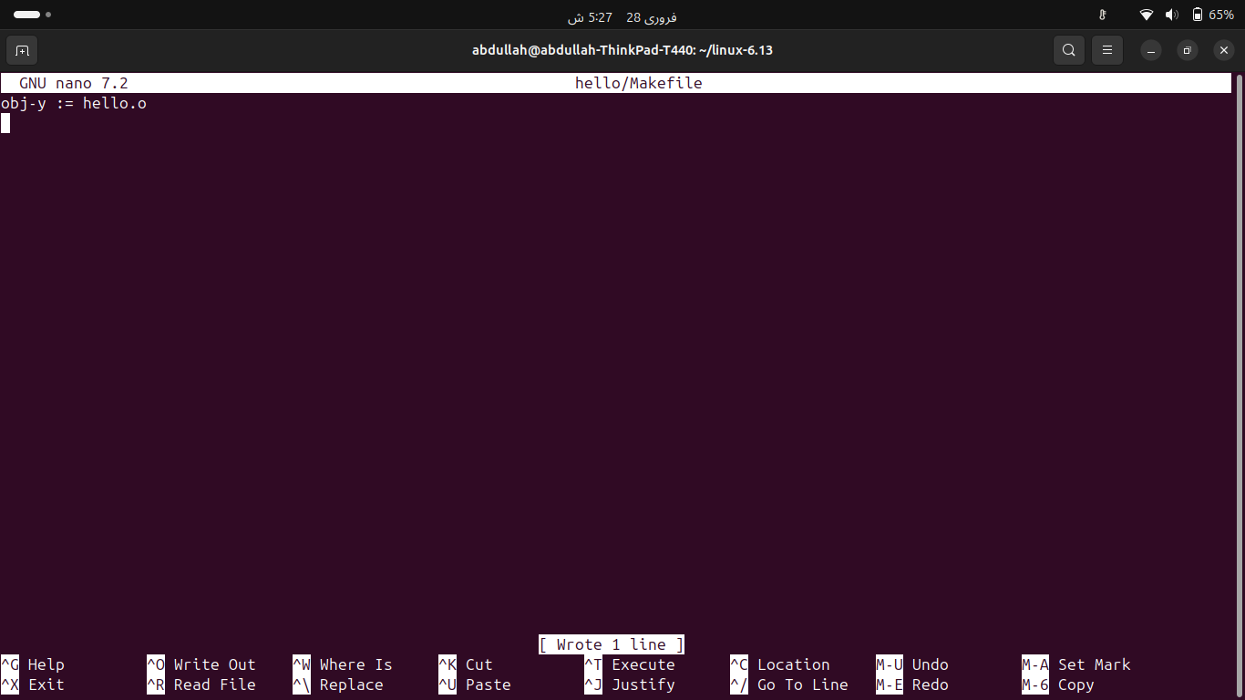
Fig 4.2 – hello/Makefile with obj-y := hello.o

4c – Register hello/ in the Top-Level Makefile
In kernel 6.13 the core-y variable is initialised empty inside an ifeq block. It was updated to include hello/:
core-y := hello/
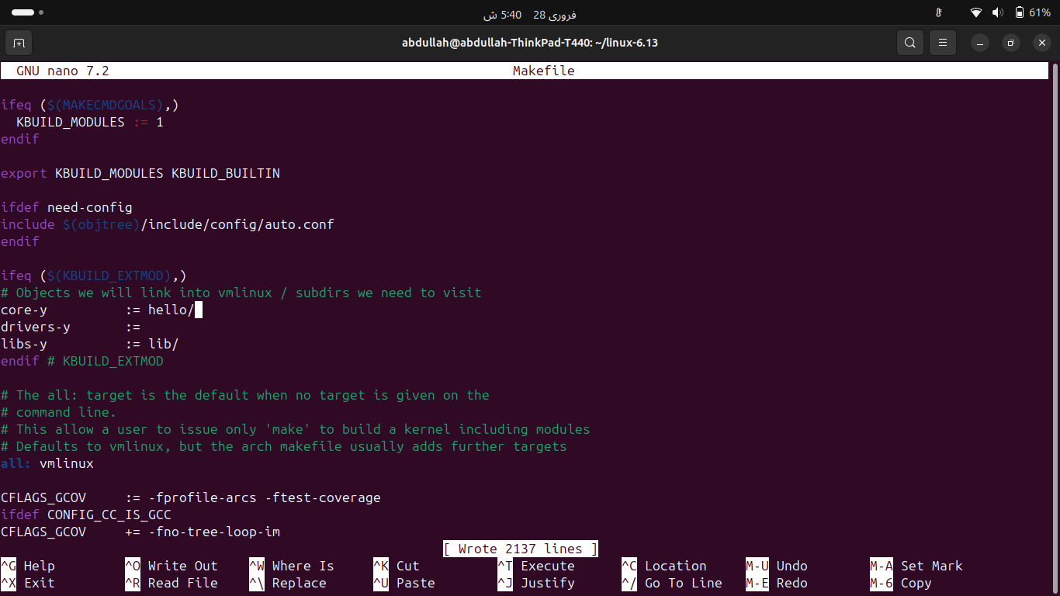
Fig 4.3 – Top-level Makefile showing core-y := hello/ inside the ifeq block
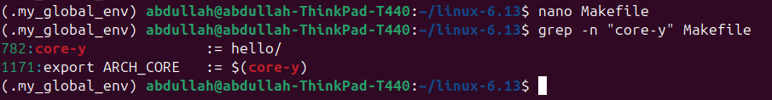
Fig 4.4 – Verification of core-y change via grep

4d – Add the System Call to the System Call Table
The syscall table at arch/x86/entry/syscalls/syscall_64.tbl was edited. The common section ended at entry 466, so the hello syscall was added as entry 467:
467 common hello sys_hello
Fig 4.5 – syscall_64.tbl showing entry 467 common hello sys_hello

4e – Add the System Call Prototype to the Header
The function prototype was added to include/linux/syscalls.h just before the final #endif:
asmlinkage long sys_hello(void);
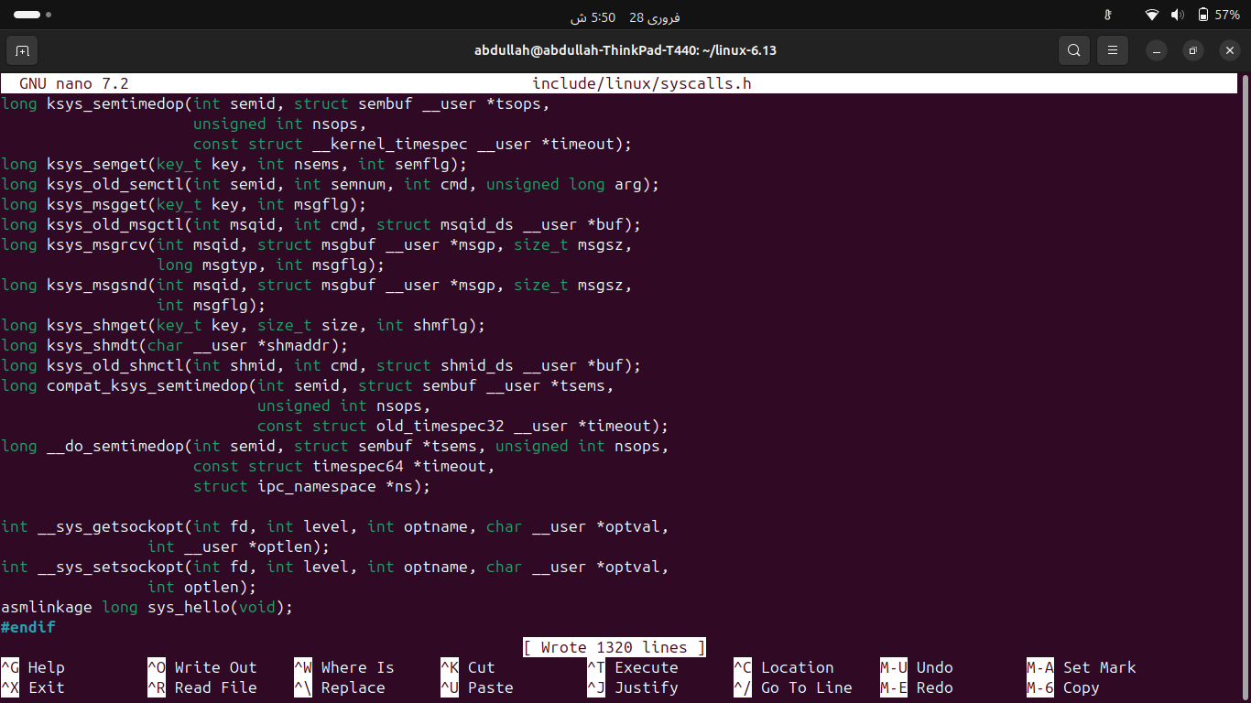
Fig 4.6 – syscalls.h showing asmlinkage long sys_hello(void) added

Step 5 – Configure the Kernel
The running kernel's config was copied as the base, certificate keys were disabled proactively, and defaults applied for all new options:
cp /boot/config-$(uname -r) .config
scripts/config --disable SYSTEM_TRUSTED_KEYS
scripts/config --disable SYSTEM_REVOCATION_KEYS
make olddefconfig
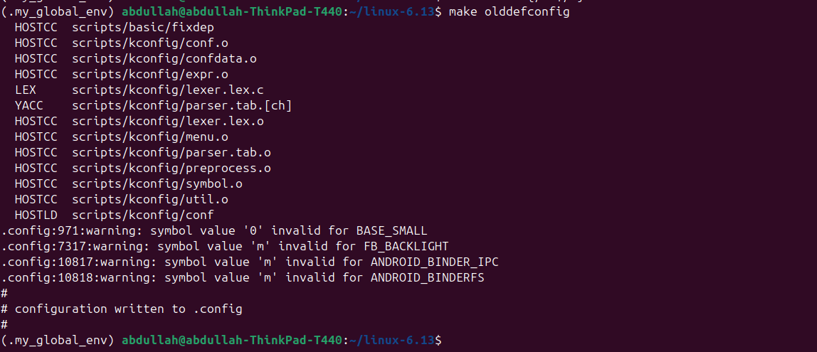
Fig 5.1 – make olddefconfig completing without errors

Step 6 – Compile the Kernel
The kernel was compiled using all available CPU cores. This took approximately 2.5–3 hours on the ThinkPad T440:
make -j$(nproc) 2>&1 | tee build.log
Note: -j$(nproc) parallelises compilation across all CPU cores. CPU ran at 100% with temperatures of 73-75°C throughout — normal for kernel compilation.
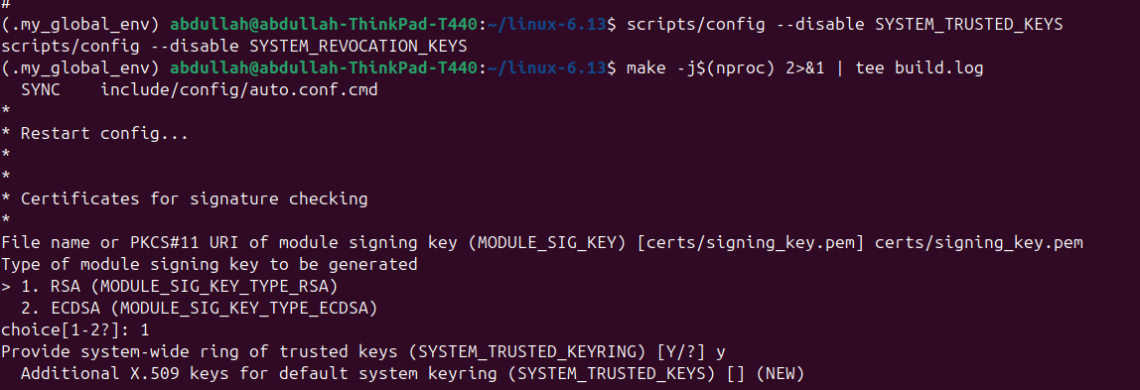
Fig 6.1 – Kernel compilation in progress (drivers being compiled)
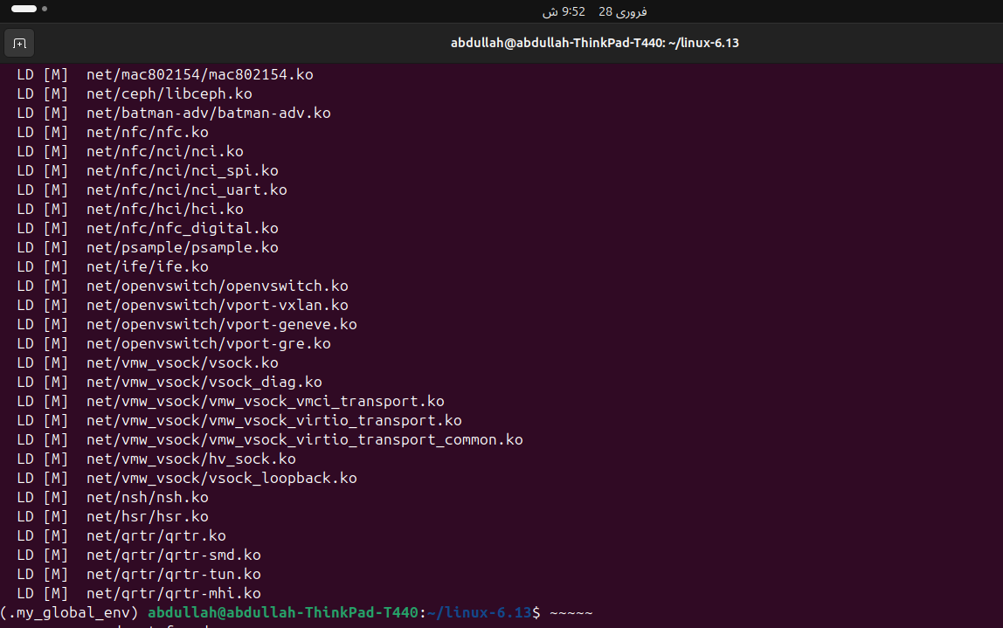
Fig 6.2 – Kernel compilation successfully completed — bzImage ready

Step 7 – Install Modules and the Kernel
Kernel modules and the kernel image were installed into the system:
sudo make modules_install
sudo make install
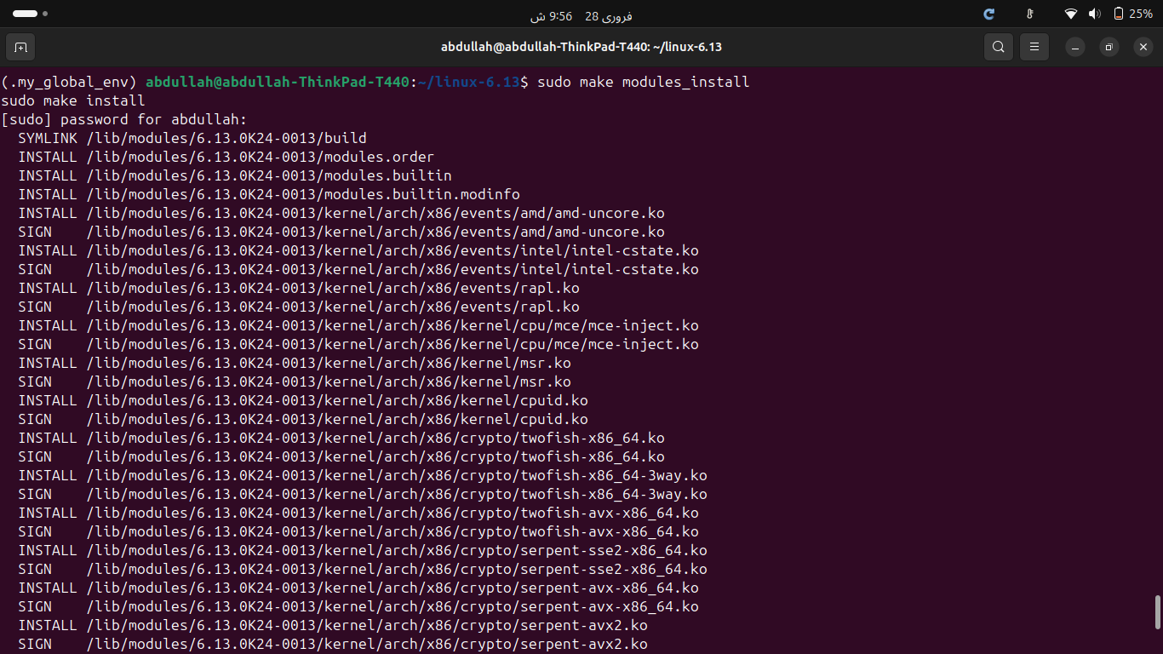
Fig 7.1 – sudo make modules_install output
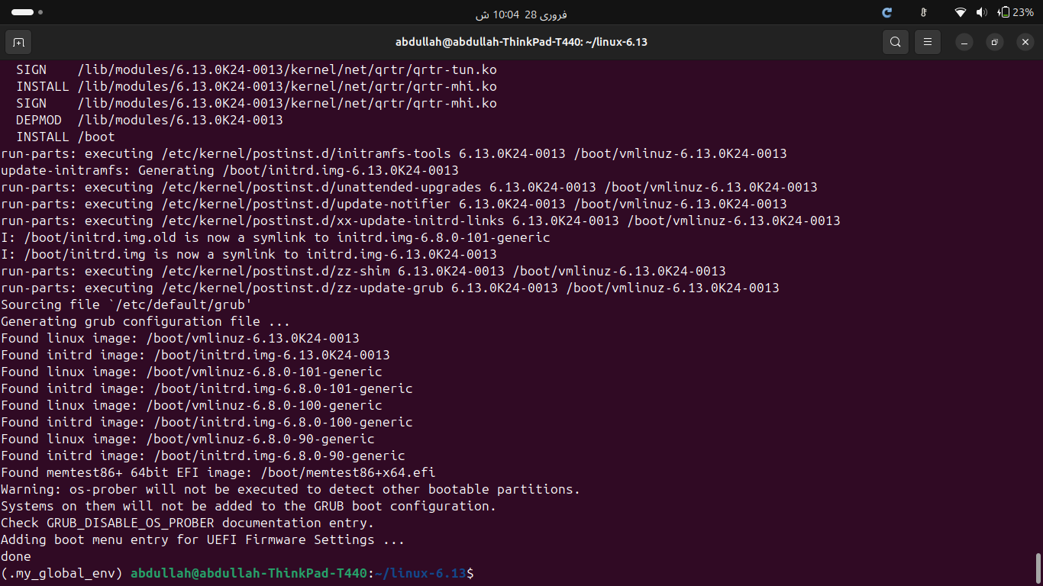
Fig 7.2 – sudo make install output

Step 8 – Create the Initial RAM Filesystem
An initramfs image was generated for the new kernel as required by the lab manual:
sudo update-initramfs -c -k 6.13.0K24-0013
Fig 8.1 – update-initramfs generating /boot/initrd.img-6.13.0K24-0013

Step 9 – Update GRUB and Reboot
GRUB was updated to detect and include the new kernel, then the system was rebooted:
sudo update-grub
sudo reboot
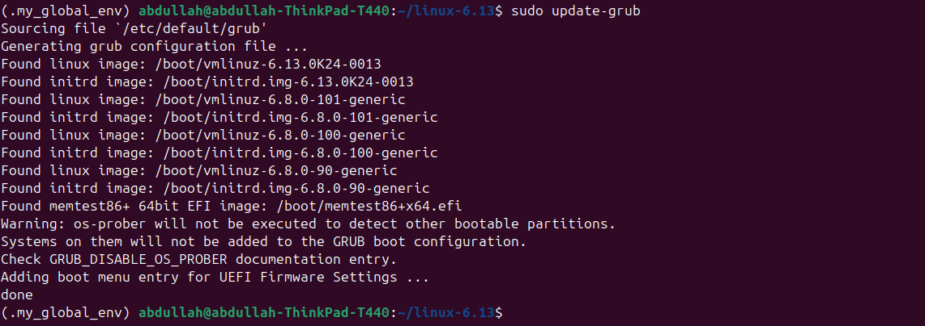
Fig 9.1 – update-grub detecting the new 6.13.0K24-0013 kernel entry

Step 10 – Verify the New Kernel
After rebooting into the new kernel, the following verifications were performed as required by the lab manual:

Verify uname -r shows roll number
uname -r
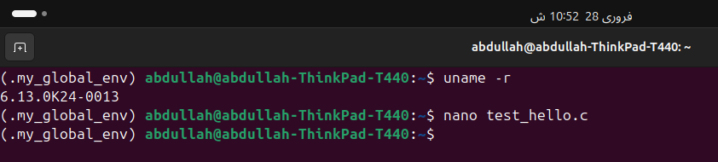
Fig 10.1 – uname -r output: 6.13.0K24-0013

Verify /boot contains new kernel files
ls /boot | grep 6.13.0K24-0013
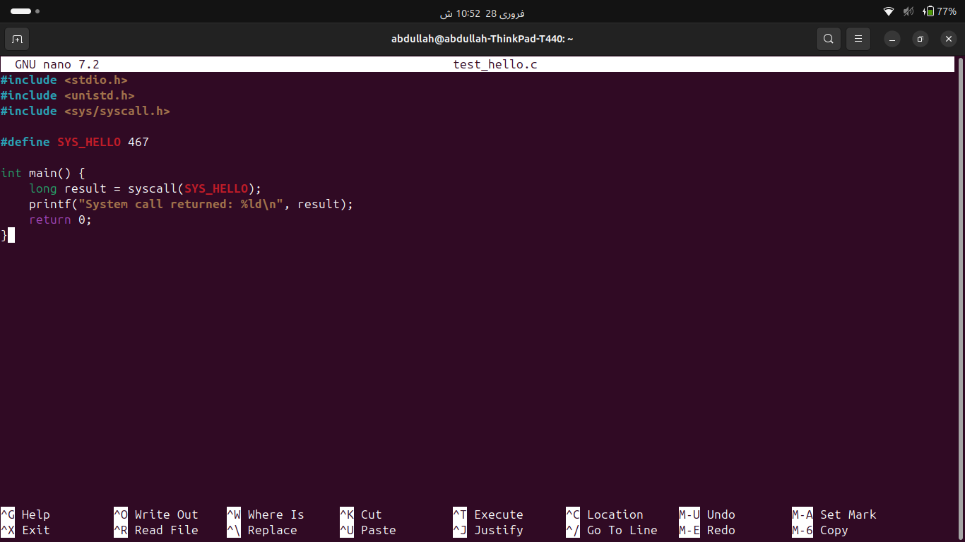
Fig 10.2 – /boot directory containing config, initrd, System.map and vmlinuz for new kernel

Step 11 – Write and Run the Test Program
A C program was written to invoke the hello system call using syscall number 467:
#include <stdio.h>
#include <unistd.h>
#include <sys/syscall.h>
#define SYS_HELLO 467
int main() {
long result = syscall(SYS_HELLO);
printf("System call returned: %ld\n", result);
return 0;
}
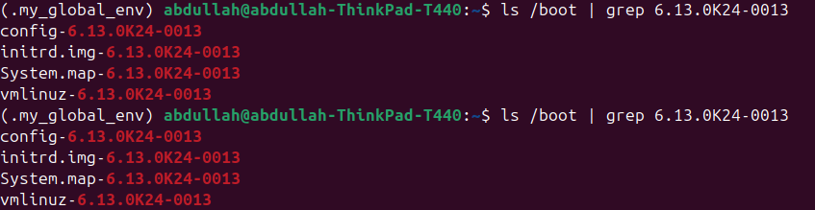
Fig 11.1 – Compiling and running test_hello: System call returned: 0

The kernel log was checked to confirm the Hello World message was printed:
sudo dmesg | grep 'Hello World'
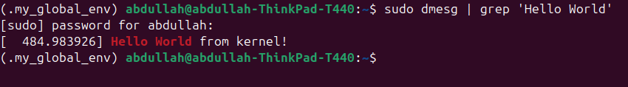
Fig 11.2 – dmesg confirming: Hello World from kernel!

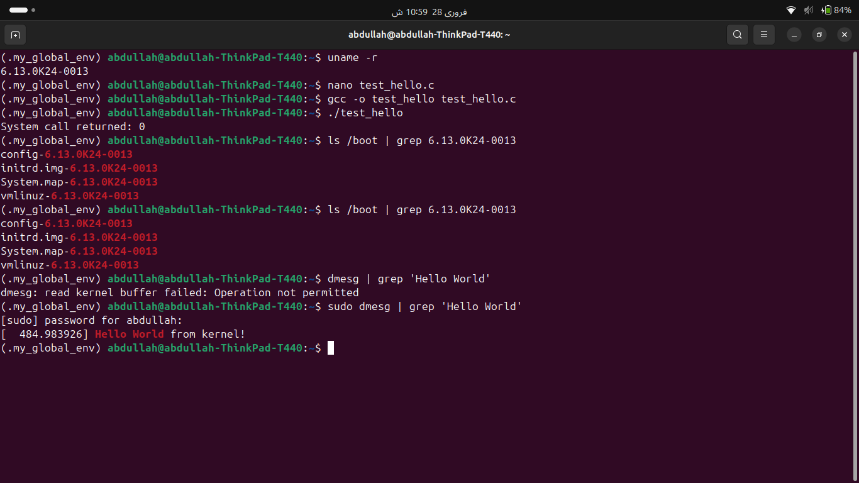
Fig 11.3 – Final verification: all steps completed successfully

Summary
All tasks were completed successfully:
- Downloaded Linux kernel 6.13 source from kernel.org
- Renamed kernel to k240013 via EXTRAVERSION = -k240013 in the Makefile
- Created hello/hello.c implementing SYSCALL_DEFINE0(hello) that prints to the kernel log
- Registered the system call in syscall_64.tbl as entry 467 and added prototype to syscalls.h
- Disabled SYSTEM_TRUSTED_KEYS and ran make olddefconfig for clean configuration
- Compiled kernel with make -j$(nproc) — took ~2.5 hours on ThinkPad T440
- Installed modules and kernel, generated initramfs with update-initramfs
- Updated GRUB and rebooted into the custom kernel
- Verified uname -r displays 6.13.0K24-0013
- Wrote and ran test program invoking sys_hello via syscall(467) — returned 0
- Confirmed dmesg shows 'Hello World from kernel!' message

Prepared by: Abdullah Sonija | Roll No: k240013 | CS2006 Operating Systems | Spring 2026 | FAST-NUCES Karachi

